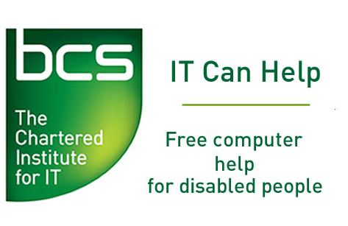 | IT Can Help

Self-Declaration of Convictions, Cautions and Charges Form (for applicants in Scotland only)

The information on this form is confidential and will only be seen by approved and nominated individuals within IT Can Help. This form will be stored and disposed of in accordance with IT Can Help's Policy on the Secure Handling of Disclosure Information.

All applicants for voluntary posts in Scotland working with Protected Adults must complete this form and send it by post to the address shown in the declaration section below.

Name of applicant:.........................................................................................

Address of applicant:.....................................................................................................................

Name of Post Applied for: .........................................................................

Question | Write  YES or NO  in the box below | If Yes…
Have you ever been charged with, cautioned or convicted of any criminal offence? |  | Please give details on next page
Are you at present the subject of a criminal investigation or do you have a prosecution pending? |  | Please give details on next page and the reasons for this.
Have you ever been the subject of disciplinary action by your employer because of alleged harmful conduct towards children or ‘vulnerable’ adults? |  | Please give details on next page
Have you been disqualified from, or refused, any post involving the care of children or vulnerable adults? In Scotland this includes being on the Disqualified from Working with Children List or the Disqualified from Working with Adults List; In England, Wales and Northern Ireland this includes the ISA Children's Barred List or the ISA Vulnerable Adults' Barred List; |  | Please give details on next page

Details about convictions, charges or cautions

Please provide detailed information under each of these headings if they apply to you. This will enable us to process your application quicker. We may also contact you by telephone if you have not provided sufficient information on this form. Attach a separate sheet of paper if required.

Convictions, charges and cautions (Give the name of the charge, conviction or caution, the dates and the sentence for each).

Please describe the reasons and circumstances that led to the offence: what happened, when, where and who else was involved.

If you were charged with an offence and no further action was taken, or you received a police caution, please give details about the reasons for this.

If applicable, how has your behaviour or life changed since your convictions, charges or cautions?

Please use the space below if there is more information that you would like to provide.

Declaration

To help us ensure that we are complying with all legislation for protecting vulnerable adults, please complete the following declaration.

● I confirm that the information contained on this form is true and accurate.

● I confirm that I am not barred from working with children or protected adults as in the Protecting Vulnerable Groups Scheme 2007 (Scotland) or the Vetting and Barring Scheme (England & Wales and Northern Ireland).

● After I have been appointed, if I am charged, cautioned or convicted of any offence that may affect my suitability to continue to do regulated work with adults; or if I become the subject of a police and/or social work department (children’s or adult services) investigation, I agree to inform immediately, in writing, the following person:
IT Can Help National Organiser (Scotland), 16B Hailes Gardens, Edinburgh,
EH13 0JL

● I confirm that:
(a) I am a British Citizen or an Irish Citizen
(b) I have been granted leave to remain in the United Kingdom and that the voluntary work I have agreed to undertake is unpaid and is permitted in terms of my immigration status.
(Delete the option that does not apply).

Sign and print your name.............................................................................

Date...................................

Telephone Number …..............................

Please return this form in an envelope marked

PRIVATE AND CONFIDENTIAL
Self-Declaration (Scotland)

To:

IT Can Help National Organiser (Scotland)
16B Hailes Gardens
Edinburgh
EH13 0JL

